**K L HYDERABAD**

**FRESHMAN ENGINEERING DEPARTMENT**

**A Project-Based Lab Report**

**On**

**CURRENCY CONVERTER**

**SUBMITTED BY:**

I.D NUMBER NAME

2110030359 BOPPELLA CHIHNITA REDDY

**UNDER THE ESTEEMED GUIDANCE OF**

**Dr. Mahesh Babu Arrama**

**Associate Professor**



**KONERU LAKSHMAIAH EDUCATION FOUNDATION**

(Deemed to be University)

Moinabad Road, Aziz Nagar, Hyderabad - 500075

**DEPARTMENT OF BASIC ENGINEERING SCIENCES**



**CERTIFICATE**

This is to certify that the project-based laboratory report entitled “CURRENCY CONVERTOR” submitted by Ms**. BOPPELLA CHIHNITA REDDY** bearing Regd. No. 2110030359 to the **Department of Basic Engineering Sciences, KL University** in partial fulfillment of the requirements for the completion of a project in “Computational Thinking For Object-Oriented Programming-21CS1203”course in I B Tech II Semester, is a bonafide record of the work carried out by him/her under my supervision during the academic year 2020-21.

PROJECT SUPERVISOR HEAD OF THE DEPARTMENT

Dr. Mahesh Babu Arrama Dr. G. REKHA

**ACKNOWLEDGEMENTS**

It is great pleasure for me to express my gratitude to our honorable President **Sri. Koneru Satyanarayana**, for giving the opportunity and platform with facilities in accomplishing the project-based laboratory report.

I express my sincere gratitude to our Principal **Dr. L. Koteswara Rao** for his administration of our academic growth.

I express sincere gratitude to our Coordinator **Dr. G.Rekha** for her leadership and constant motivation provided in the successful completion of our academic semester. I record it as my privilege to deeply thank you for providing us with the efficient faculty and facilities to make our ideas into reality.

I express my sincere thanks to our project supervisor **Dr. Mahesh Babu Arram** for her novel association of ideas, encouragement, appreciation, and intellectual zeal which motivated us to venture into this project successfully.

Finally, it is pleased to acknowledge the indebtedness to all those who devoted themselves directly or indirectly to making this project report success.

Name: BOPPELLA CHIHNITA REDDY

Regd . No: 2110030359

**ABSTRACT**

This project is about the CURRENCY CONVERTER in GUI application.

The main of the project is to create a GUI (GRAPHICAL USER INTERFACE) application. Traveling throughout the world is a dream for most of us. The main problem regarding this is that currency conversion isn’t understood by everyone and isn’t easily accessible sometimes. So, design a GUI interface that contains details like the selection of two countries, the rate of their currency at that moment, and the converted amount. Store all this information in a file and display them on the screen.

**INDEX**

|  |  |  |
| --- | --- | --- |
| **S.NO** | **TITLE** | **PAGE NO** |
| 1 | Introduction | 6 |
| 2 | Aim of the Project | 7 |
| 2.1 | Advantages & Disadvantages | 7 |
| 3 | Software & Hardware Details | 8 |
| 5 | Implementation | 9-21 |
| 6 | Outputs/Screen-Shots | 22-24 |
| 7 | Conclusion | 25 |

**INTRODUCTION**

The main of the project is to create a GUI (Graphical User Interface) application for registering in sports. GUI is the interface where images are used to represent different choices. The choices are designed as per the requirement of the end-user applications. In this, we use text fields, combo-box, labels, and radio buttons. We use text fields for entering the data during the runtime.

We have to select the country from which currency it should be converted to the other currency and then we keep the currency value. Now we need to enter the currency value and increase or decrease and once we click submit button it will get saved in the file

We have to write the final output in files using the file Writer concept. We can create our design in a very attractive manner by using graphical user interfaces.

**AIM**

The main of this project is to create the details of the car models which will be helpful to the customers when they visit the showrooms.

**Advantages:-**

* GUI is very attractive and multi-colored.
* Programmer or user need not have to understand the working of the computer system.
* Userser should be able to use the application immediately, find the functionality they want, and not get frustrated.
* Users need not know any programming languages.

**Disadvantages:-**

* Java mainly works on storage and does not focus on the backup of data.
* GUI uses more computer memory as the main is to make it user-friendly and not resource-optimized.
* GUI becomes more complex if the user needs to communicate with the computer directly.
* Making changes to menus is not simple, or even reliable.

**SYSTEM REQUIREMENTS**

* **SOFTWARE REQUIREMENTS:**

The major software requirements of the project are as follows:

Language: JAVA

Operating system**:** Windows XP or later.

Tools: Eclipse IDE

* **HARDWARE REQUIREMENTS:**

The hardware requirements that map towards the software are as follows:

RAM: 16 GB

Processor: i7

**IMPLEMENTATION**

**package** p1;

**import** java.awt.EventQueue;

**import** javax.swing.JFrame;

**import** javax.swing.JLabel;

**import** javax.swing.JOptionPane;

**import** java.awt.Font;

**import** javax.swing.JTextField;

**import** javax.swing.JComboBox;

**import** javax.swing.DefaultComboBoxModel;

**import** javax.swing.ImageIcon;

**import** javax.swing.JSpinner;

**import** javax.swing.SpinnerNumberModel;

**import** javax.swing.JSpinner.DefaultEditor;

**import** java.awt.event.ItemListener;

**import** java.io.FileWriter;

**import** java.awt.event.ItemEvent;

**import** javax.swing.event.ChangeListener;

**import** javax.swing.event.ChangeEvent;

**import** java.awt.Color;

**import** javax.swing.JButton;

**import** java.awt.event.ActionListener;

**import** java.awt.event.ActionEvent;

**public** **class** CURRENCY_CONVERTER {

**private** JFrame frmCurrencyConverter;

**private** JTextField txtvalue;

**private** JTextField txtcur;

JSpinner sv;

JSpinner sv_1;

**double** v,s,s1;

**private** JTextField txtcur1;

JComboBox cmbcountry_1;

/**

* Launch the application.

*/

**public** **static** **void** main(String[] args) {

EventQueue.*invokeLater*(**new** Runnable() {

**public** **void** run() {

**try** {

CURRENCY_CONVERTER window = **new** CURRENCY_CONVERTER();

window.frmCurrencyConverter.setVisible(**true**);

} **catch** (Exception e) {

e.printStackTrace();

}

}

});

}

/**

* Create the application.

*/

**public** CURRENCY_CONVERTER() {

initialize();

}

/**

* Initialize the contents of the frame.

*/

**private** **void** initialize() {

frmCurrencyConverter = **new** JFrame();

frmCurrencyConverter.setBounds(100, 100, 450, 300);

frmCurrencyConverter.setDefaultCloseOperation(JFrame.***EXIT_ON_CLOSE***);

frmCurrencyConverter = **new** JFrame();

frmCurrencyConverter.getContentPane().setBackground(Color.***CYAN***);

frmCurrencyConverter.setBounds(100, 100, 1013, 657);

frmCurrencyConverter.setDefaultCloseOperation(JFrame.***EXIT_ON_CLOSE***);

frmCurrencyConverter.getContentPane().setLayout(**null**);

JLabel lblSelectCountry = **new** JLabel("CURRENCY CONVERTER");

lblSelectCountry.setBackground(Color.***CYAN***);

lblSelectCountry.setForeground(**new** Color(0, 0, 139));

lblSelectCountry.setFont(**new** Font("Times New Roman", Font.***BOLD***, 55));

lblSelectCountry.setBounds(99, 11, 718, 87);

frmCurrencyConverter.getContentPane().add(lblSelectCountry);

JLabel lblEnterValue = **new** JLabel("Enter Value :");

lblEnterValue.setForeground(**new** Color(153, 50, 204));

lblEnterValue.setFont(**new** Font("Times New Roman", Font.***BOLD***, 29));

lblEnterValue.setBounds(25, 297, 193, 73);

frmCurrencyConverter.getContentPane().add(lblEnterValue);

JLabel lblEquivalentCurrencyValue = **new** JLabel("CURRENCY VALUE");

lblEquivalentCurrencyValue.setForeground(**new** Color(65, 105, 225));

lblEquivalentCurrencyValue.setFont(**new** Font("Times New Roman", Font.***BOLD***, 25));

lblEquivalentCurrencyValue.setBounds(25, 405, 273, 78);

frmCurrencyConverter.getContentPane().add(lblEquivalentCurrencyValue);

JComboBox cmbcountry = **new** JComboBox();

cmbcountry.setFont(**new** Font("Times New Roman", Font.***BOLD***, 25));

cmbcountry.setBackground(Color.***ORANGE***);

cmbcountry.addItemListener(**new** ItemListener() {

**public** **void** itemStateChanged(ItemEvent e) {

/*String ImgPath1 = "E:\\Currency Converter\\";

String ImgPath2 = "E:\\Currency Converter\\";*/

**if**(cmbcountry.getSelectedIndex()==0)

{

sv.setValue(0);

sv.setEnabled(**false**);

txtcur.setText(**null**);

txtvalue.setText(**null**);

}

**if**(cmbcountry.getSelectedIndex()==1)

{

/*ImgPath1 = ImgPath1 +"india.png";

ImgPath2 = ImgPath2 + "rupee.jpg";*/

txtcur.setText("Rupee");

sv.setValue(0);

txtvalue.setText(**null**);

sv.setEnabled(**true**);

}

**if**(cmbcountry.getSelectedIndex()==2)

{

/*ImgPath1 = ImgPath1 +"singapore.png";

ImgPath2 = ImgPath2 + "singd.jpeg";*/

txtcur.setText("Singapore Dollar");

sv.setValue(0);

txtvalue.setText(**null**);

sv.setEnabled(**true**);

}

**if**(cmbcountry.getSelectedIndex()==3)

{

/*ImgPath1 = ImgPath1 +"australia.png";

ImgPath2 = ImgPath2 + "ausd.png";*/

txtcur.setText("Australian Dollar");

sv.setValue(0);

txtvalue.setText(**null**);

sv.setEnabled(**true**);

}

/*if(cmbcountry.getSelectedIndex()==4)

{

ImgPath1 = ImgPath1 +"switzerland.png";

ImgPath2 = ImgPath2 + "swic.jpeg";

txtcur.setText("Swiss Franc");

sv.setValue(0);

txtvalue.setText(null);

sv.setEnabled(true);

}

if(cmbcountry.getSelectedIndex()==5)

{

ImgPath1 = ImgPath1 +"dubai.png";

ImgPath2 = ImgPath2 + "dubaic.png";

txtcur.setText("Dirham");

sv.setValue(0);

txtvalue.setText(null);

sv.setEnabled(true);

}

if(cmbcountry.getSelectedIndex()==6)

{

ImgPath1 = ImgPath1 +"japan.png";

ImgPath2 = ImgPath2 + "japanc.png";

txtcur.setText("Yen");

sv.setValue(0);

txtvalue.setText(null);

sv.setEnabled(true);

}

if(cmbcountry.getSelectedIndex()==7)

{

ImgPath1 = ImgPath1 +"russia.png";

ImgPath2 = ImgPath2 + "russiac.png";

txtcur.setText("Ruble");

sv.setValue(0);

txtvalue.setText(null);

sv.setEnabled(true);

}

if(cmbcountry.getSelectedIndex()==8)

{

ImgPath1 = ImgPath1 +"ukraine.png";

ImgPath2 = ImgPath2 + "ukrainec.png";

txtcur.setText("Hryvnia");

sv.setValue(0);

txtvalue.setText(null);

sv.setEnabled(true);

}

if(cmbcountry.getSelectedIndex()==9)

{

ImgPath1 = ImgPath1 +"germany.png";

ImgPath2 = ImgPath2 + "germanyc.jpeg";

txtcur.setText("Euro");

sv.setValue(0);

txtvalue.setText(null);

sv.setEnabled(true);

}

if(cmbcountry.getSelectedIndex()==10)

{

ImgPath1 = ImgPath1 +"brazil.png";

ImgPath2 = ImgPath2 + "brazilc.png";

txtcur.setText("Brazilian Real");

sv.setValue(0);

txtvalue.setText(null);

sv.setEnabled(true);

}*/

/*ImageIcon ImgIcon1 = new ImageIcon(ImgPath1);

ImageIcon ImgIcon2 = new ImageIcon(ImgPath2);

lblcur.setIcon(ImgIcon2);

lblflag.setIcon(ImgIcon1);*/

}

});

cmbcountry.setModel(**new** DefaultComboBoxModel(**new** String[] {"SELECT COUNTRY", "INDIA", "SINGAPORE", "AUSTRALIA"}));

cmbcountry.setBounds(10, 135, 302, 53);

frmCurrencyConverter.getContentPane().add(cmbcountry);

sv = **new** JSpinner();

sv.setBackground(**new** Color(0, 128, 128));

sv.addChangeListener(**new** ChangeListener() {

**public** **void** stateChanged(ChangeEvent e) {

**if**(Double.*parseDouble*(sv.getValue().toString())>=1)

{

**if**(cmbcountry.getSelectedIndex()==1 && cmbcountry_1.getSelectedIndex()==1)

{

s = Double.*parseDouble*(sv.getValue().toString())*0.013;

**if**((Double.*parseDouble*(sv.getValue().toString())>=1))

txtvalue.setText(Double.*toString*(s)+" swiss franc");

}

**if**(cmbcountry.getSelectedIndex()==1 && cmbcountry_1.getSelectedIndex()==2 )

{

s= Double.*parseDouble*(sv.getValue().toString())*0.048;

**if**((Double.*parseDouble*(sv.getValue().toString())>=1))

txtvalue.setText(Double.*toString*(s)+" dirham");

}

**if**(cmbcountry.getSelectedIndex()==1 && cmbcountry_1.getSelectedIndex()==3)

{

s = Double.*parseDouble*(sv.getValue().toString())*1.68;

**if**((Double.*parseDouble*(sv.getValue().toString())>=1))

txtvalue.setText(Double.*toString*(s)+" yen");

}

**if**(cmbcountry.getSelectedIndex()==2 && cmbcountry_1.getSelectedIndex()==1)

{

s = Double.*parseDouble*(sv.getValue().toString())*0.70;

**if**((Double.*parseDouble*(sv.getValue().toString())>=1))

txtvalue.setText(Double.*toString*(s)+" swiss franc");

}

**if**(cmbcountry.getSelectedIndex()==2 && cmbcountry_1.getSelectedIndex()==2)

{

s = Double.*parseDouble*(sv.getValue().toString())*2.68;

**if**((Double.*parseDouble*(sv.getValue().toString())>=1))

txtvalue.setText(Double.*toString*(s)+" dhiram");

}

**if**(cmbcountry.getSelectedIndex()==2 && cmbcountry_1.getSelectedIndex()==3)

{

s = Double.*parseDouble*(sv.getValue().toString())*93.70;

**if**((Double.*parseDouble*(sv.getValue().toString())>=1))

txtvalue.setText(Double.*toString*(s)+" yen ");

}

**if**(cmbcountry.getSelectedIndex()==3 && cmbcountry_1.getSelectedIndex()==1)

{

s = Double.*parseDouble*(sv.getValue().toString())*0.69;

**if**((Double.*parseDouble*(sv.getValue().toString())>=1))

txtvalue.setText(Double.*toString*(s)+" swiss france");

}

**if**(cmbcountry.getSelectedIndex()==3 && cmbcountry_1.getSelectedIndex()==2)

{

s = Double.*parseDouble*(sv.getValue().toString())*2.66;

**if**((Double.*parseDouble*(sv.getValue().toString())>=1))

txtvalue.setText(Double.*toString*(s)+" dhiram");

}

**if**(cmbcountry.getSelectedIndex()==3 && cmbcountry_1.getSelectedIndex()==3)

{

s = Double.*parseDouble*(sv.getValue().toString())*93.13;

**if**((Double.*parseDouble*(sv.getValue().toString())>=1))

txtvalue.setText(Double.*toString*(s)+" yen");

}

}

**else**

{

txtvalue.setText(Integer.*toString*(0));

}

}

});

sv.setModel(**new** SpinnerNumberModel(0, 0, 100000, 1));

sv.setFont(**new** Font("Times New Roman", Font.***BOLD***, 25));

sv.setBounds(300, 297, 96, 56);

sv.setEnabled(**false**);

((DefaultEditor)sv.getEditor()).getTextField().setEditable(**false**);

frmCurrencyConverter.getContentPane().add(sv);

txtvalue = **new** JTextField();

txtvalue.setForeground(**new** Color(102, 0, 153));

txtvalue.setBackground(**new** Color(255, 255, 255));

txtvalue.setFont(**new** Font("Tahoma", Font.***BOLD***, 30));

txtvalue.setEditable(**false**);

txtvalue.setBounds(356, 405, 224, 78);

frmCurrencyConverter.getContentPane().add(txtvalue);

txtvalue.setColumns(10);

txtcur = **new** JTextField();

txtcur.setFont(**new** Font("Tahoma", Font.***BOLD***, 25));

txtcur.setEditable(**false**);

txtcur.setBounds(368, 202, 225, 56);

frmCurrencyConverter.getContentPane().add(txtcur);

txtcur.setColumns(10);

JButton btnClear = **new** JButton("CLEAR");

btnClear.setEnabled(**false**);

btnClear.addActionListener(**new** ActionListener() {

**public** **void** actionPerformed(ActionEvent e) {

cmbcountry.setSelectedIndex(0);

}

});

btnClear.setForeground(Color.***BLACK***);

btnClear.setFont(**new** Font("Times New Roman", Font.***BOLD***, 25));

btnClear.setBackground(Color.***BLACK***);

btnClear.setBounds(63, 522, 162, 54);

frmCurrencyConverter.getContentPane().add(btnClear);

cmbcountry_1 = **new** JComboBox();

cmbcountry_1.setFont(**new** Font("Times New Roman", Font.***BOLD***, 25));

cmbcountry_1.addItemListener(**new** ItemListener() {

**public** **void** itemStateChanged(ItemEvent e)

{

**if**(cmbcountry_1.getSelectedIndex()==0)

{

sv_1.setValue(0);

sv_1.setEnabled(**false**);

txtcur1.setText(**null**);

txtvalue.setText(**null**);

}

**if**(cmbcountry_1.getSelectedIndex()==1)

{

/*ImgPath1 = ImgPath1 +"switzerland.png";

ImgPath2 = ImgPath2 + "swic.jpeg";*/

txtcur1.setText("Swiss Franc");

sv_1.setValue(0);

txtvalue.setText(**null**);

sv_1.setEnabled(**true**);

}

**if**(cmbcountry_1.getSelectedIndex()==2)

{

/*ImgPath1 = ImgPath1 +"dubai.png";

ImgPath2 = ImgPath2 + "dubaic.png";*/

txtcur1.setText("Dirham");

sv_1.setValue(0);

txtvalue.setText(**null**);

sv_1.setEnabled(**true**);

}

**if**(cmbcountry_1.getSelectedIndex()==3)

{

/*ImgPath1 = ImgPath1 +"japan.png";

ImgPath2 = ImgPath2 + "japanc.png";*/

txtcur1.setText("Yen");

sv_1.setValue(0);

txtvalue.setText(**null**);

sv_1.setEnabled(**true**);

}

}

});

cmbcountry_1.setModel(**new** DefaultComboBoxModel(**new** String[] {"SELECT COUNTRY", "SWITZERLAND", "DUBAI", "JAPAN"}));

cmbcountry_1.setBackground(Color.***ORANGE***);

cmbcountry_1.setBounds(10, 213, 302, 45);

frmCurrencyConverter.getContentPane().add(cmbcountry_1);

txtcur1 = **new** JTextField();

txtcur1.setFont(**new** Font("Tahoma", Font.***BOLD***, 25));

txtcur1.setEditable(**false**);

txtcur1.setColumns(10);

txtcur1.setBounds(368, 135, 225, 53);

frmCurrencyConverter.getContentPane().add(txtcur1);

sv_1 = **new** JSpinner();

sv_1.setModel(**new** SpinnerNumberModel(**new** ~~Integer~~(0), **null**, **null**, **new** ~~Integer~~(1)));

sv_1.setBackground(**new** Color(0, 128, 128));

sv_1.addChangeListener(**new** ChangeListener() {

**public** **void** stateChanged(ChangeEvent e)

{

**if**(Double.*parseDouble*(sv_1.getValue().toString())>=1)

{

**if**(cmbcountry_1.getSelectedIndex()==1 && cmbcountry.getSelectedIndex()==1)

{

s = Double.*parseDouble*(sv_1.getValue().toString())*79.87;

**if**((Double.*parseDouble*(sv_1.getValue().toString())>=1))

txtvalue.setText(Double.*toString*(s)+" rupees");

}

**if**(cmbcountry_1.getSelectedIndex()==1 && cmbcountry.getSelectedIndex()==2 )

{

s= Double.*parseDouble*(sv_1.getValue().toString())*1.43;

**if**((Double.*parseDouble*(sv_1.getValue().toString())>=1))

txtvalue.setText(Double.*toString*(s)+" singapore dollar");

}

**if**(cmbcountry_1.getSelectedIndex()==1 && cmbcountry.getSelectedIndex()==3)

{

s = Double.*parseDouble*(sv_1.getValue().toString())*1.44;

**if**((Double.*parseDouble*(sv_1.getValue().toString())>=1))

txtvalue.setText(Double.*toString*(s)+" australian dollar");

}

**if**(cmbcountry_1.getSelectedIndex()==2 && cmbcountry.getSelectedIndex()==1)

{

s = Double.*parseDouble*(sv_1.getValue().toString())*20.82;

**if**((Double.*parseDouble*(sv_1.getValue().toString())>=1))

txtvalue.setText(Double.*toString*(s)+" rupees");

}

**if**(cmbcountry_1.getSelectedIndex()==2 && cmbcountry.getSelectedIndex()==2)

{

s = Double.*parseDouble*(sv_1.getValue().toString())*0.37;

**if**((Double.*parseDouble*(sv_1.getValue().toString())>=1))

txtvalue.setText(Double.*toString*(s)+" singapore dollar");

}

**if**(cmbcountry_1.getSelectedIndex()==2 && cmbcountry.getSelectedIndex()==3)

{

s = Double.*parseDouble*(sv_1.getValue().toString())*0.38;

**if**((Double.*parseDouble*(sv_1.getValue().toString())>=1))

txtvalue.setText(Double.*toString*(s)+" australian dollar");

}

**if**(cmbcountry_1.getSelectedIndex()==3 && cmbcountry.getSelectedIndex()==1)

{

s = Double.*parseDouble*(sv_1.getValue().toString())*0.59;

**if**((Double.*parseDouble*(sv_1.getValue().toString())>=1))

txtvalue.setText(Double.*toString*(s)+" rupees");

}

**if**(cmbcountry_1.getSelectedIndex()==3 && cmbcountry.getSelectedIndex()==2)

{

s = Double.*parseDouble*(sv_1.getValue().toString())*0.011;

**if**((Double.*parseDouble*(sv_1.getValue().toString())>=1))

txtvalue.setText(Double.*toString*(s)+" singapore dollar");

}

**if**(cmbcountry_1.getSelectedIndex()==3 && cmbcountry.getSelectedIndex()==3)

{

s = Double.*parseDouble*(sv_1.getValue().toString())*0.011;

**if**((Double.*parseDouble*(sv_1.getValue().toString())>=1))

txtvalue.setText(Double.*toString*(s)+" australian dollar");

}

}

**else**

{

txtvalue.setText(Integer.*toString*(0));

}

}

});

sv_1.setFont(**new** Font("Times New Roman", Font.***BOLD***, 20));

sv_1.setEnabled(**false**);

((DefaultEditor)sv_1.getEditor()).getTextField().setEditable(**false**);

sv_1.setBounds(497, 297, 96, 56);

frmCurrencyConverter.getContentPane().add(sv_1);

JButton btnstore = **new** JButton("SUBMIT");

btnstore.setForeground(**new** Color(102, 0, 0));

btnstore.setBackground(**new** Color(204, 153, 255));

btnstore.setFont(**new** Font("Times New Roman", Font.***BOLD***, 25));

btnstore.addActionListener(**new** ActionListener() {

**public** **void** actionPerformed(ActionEvent e) {

String c1,c2,cn,cn1,res;

**int** s1,s2;

c1 = (String) cmbcountry.getSelectedItem();

c2 = (String) cmbcountry_1.getSelectedItem();

s1 = (**int**) sv.getValue();

s2 = (**int**) sv_1.getValue();

cn = txtcur.getText();

cn1 = txtcur1.getText();

res = txtvalue.getText();

**try**

{

FileWriter fw = **new** FileWriter("C:\\SAMPLE\\Currency_converter.csv",**true**);

fw.write(c1+","+cn+","+c2+","+cn1+","+s1+","+s2+","+res+"\n");

fw.close();

JOptionPane.*showMessageDialog*(**null**, "SUCCESSFULLY CONVERTED");

}

**catch**(Exception E)

{

JOptionPane.*showMessageDialog*(**null**, "ERROR OCCURED");

}

}

});

btnstore.setBounds(275, 522, 151, 53);

frmCurrencyConverter.getContentPane().add(btnstore);

}

}

**OUTPUTS**

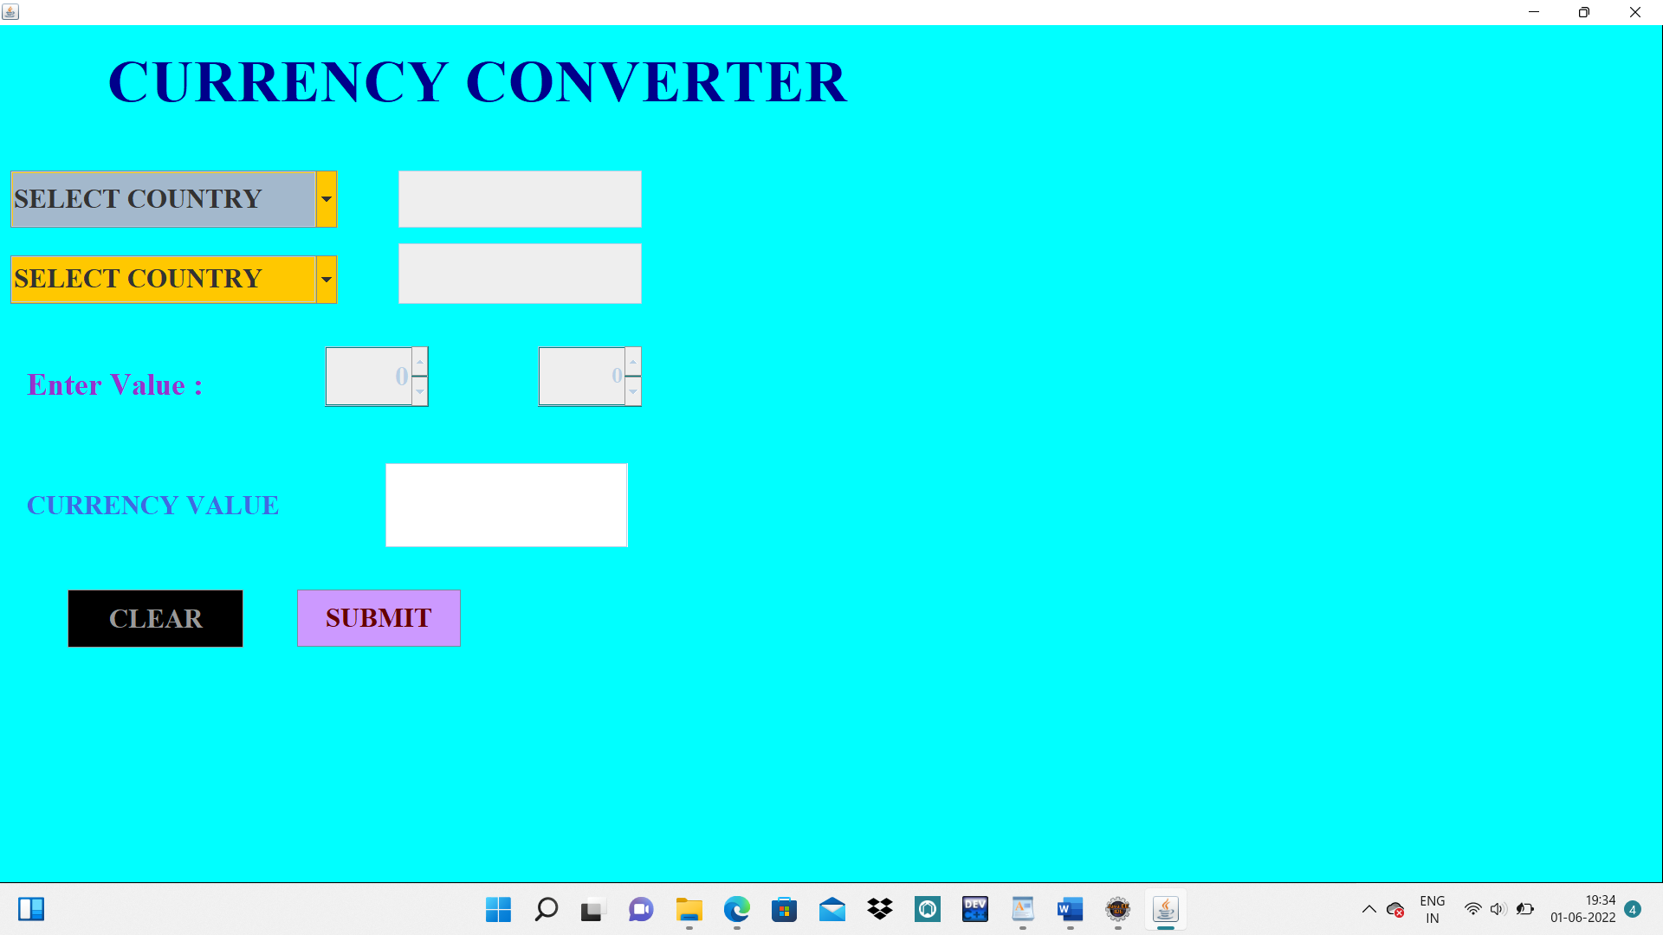

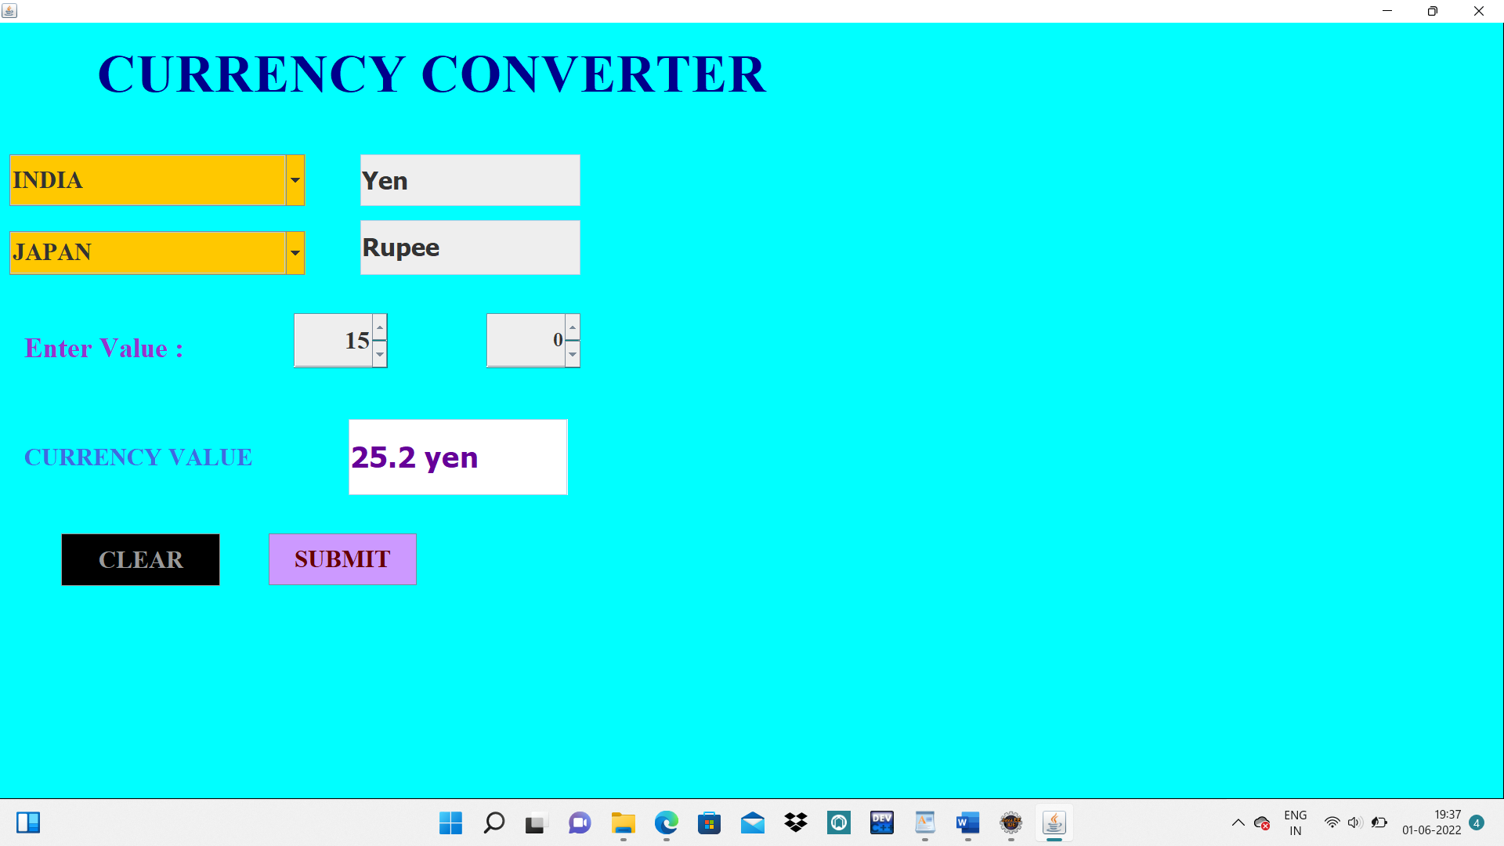

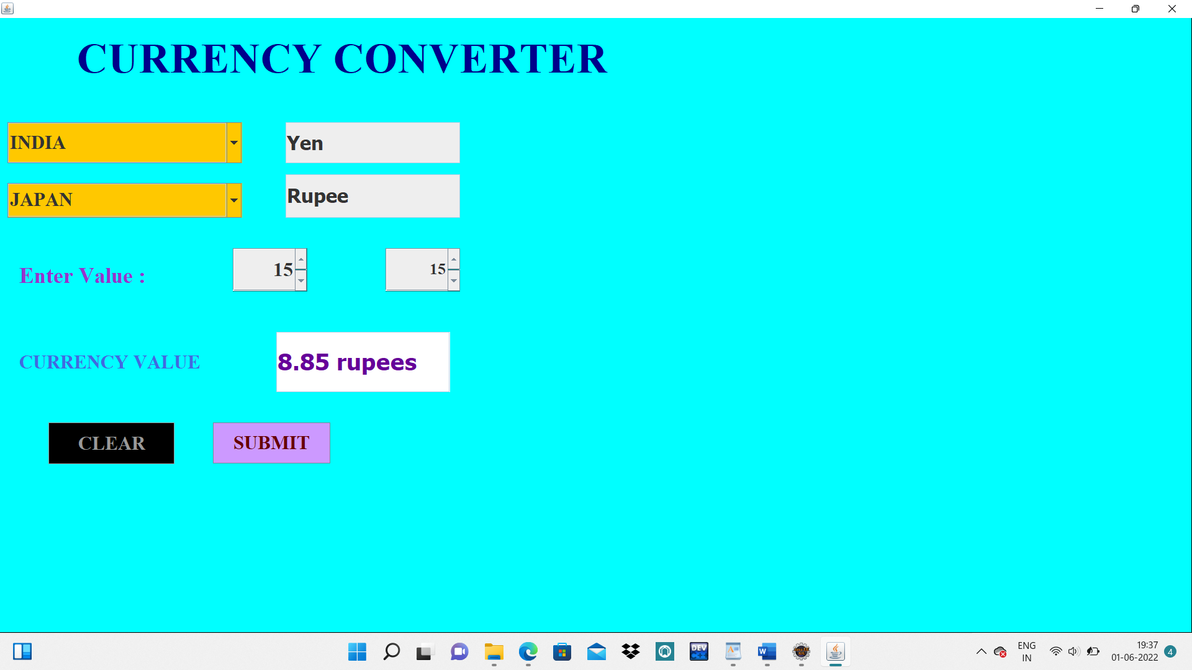

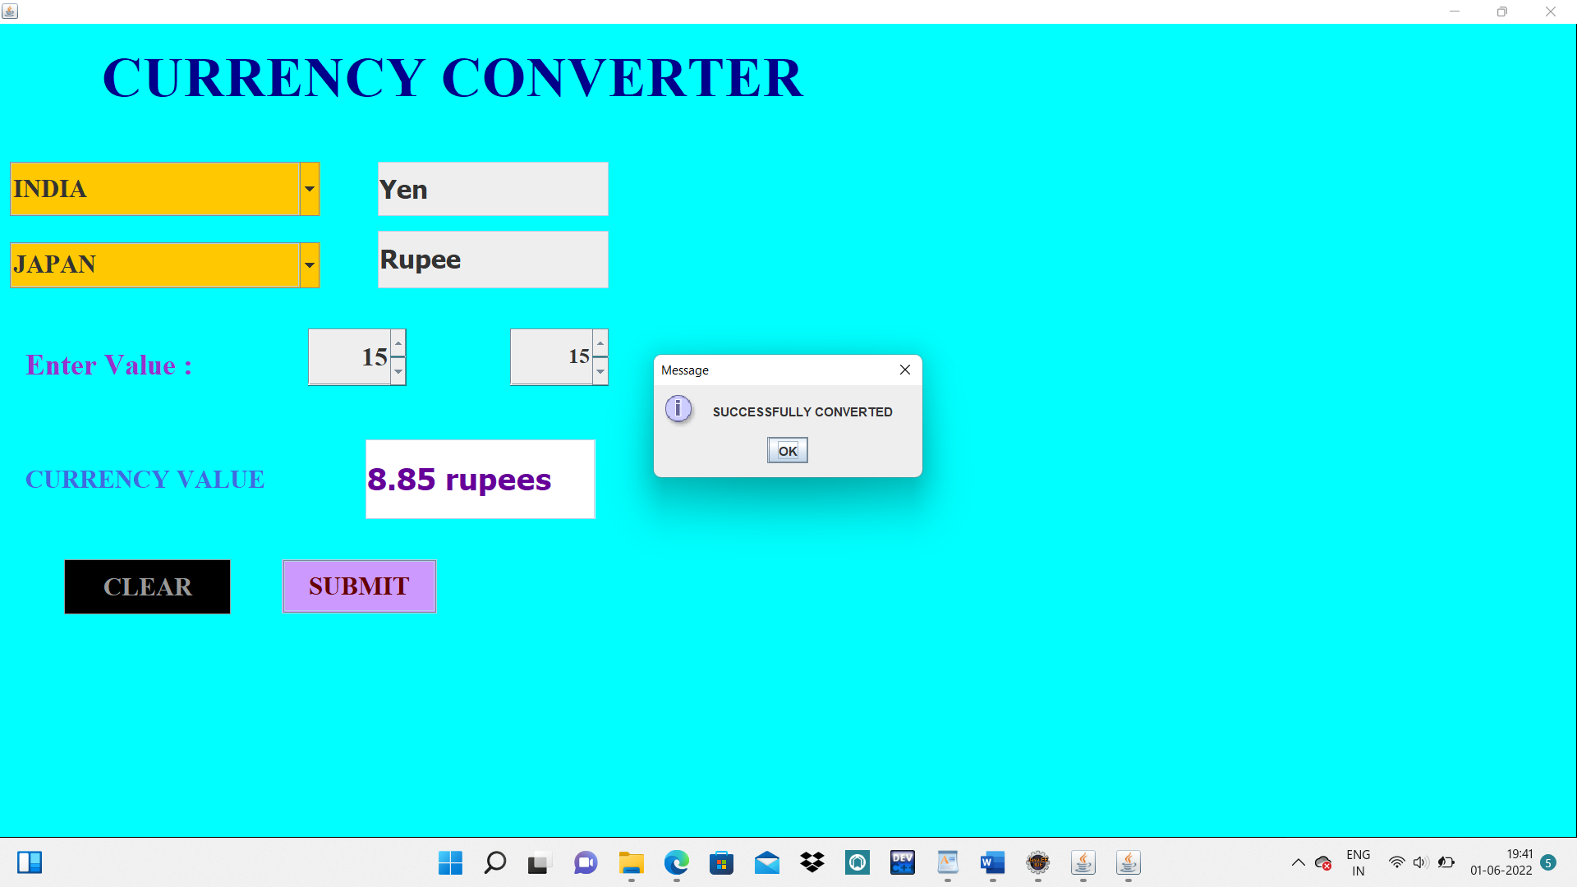

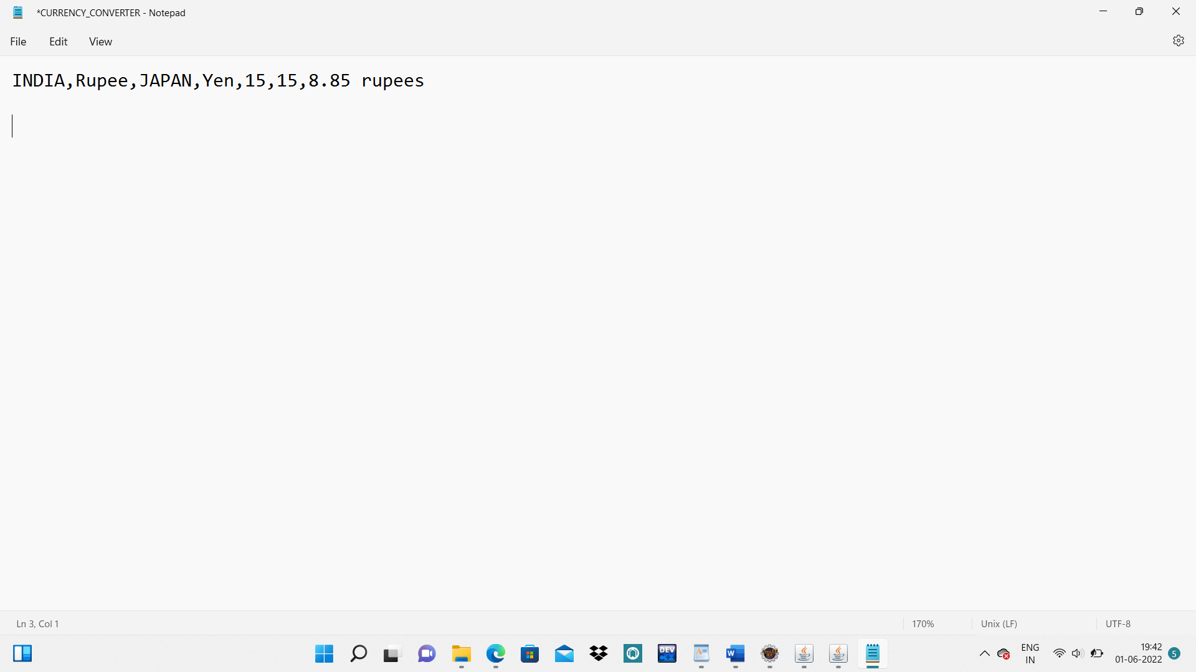

**CONCLUSION**

**& Future Work**

The main objective of this project is to create a GUI application for the currency converter.

In this project, we have created an application and we have understood the GUI clearly. By creating this application, the customers feel very at ease communicating. The currency conversion is easily understood by everyone and it is easily accessible at any place.

Finally, we have created this application. We have learned about Graphics User Interfaces.